A voltage regulator is a voltage stabilizer that is designed to automatically stabilize a constant voltage level. A voltage regulator circuit is also used to change or stabilize the voltage level according to the necessity of the circuit. Thus, a voltage regulator is used for two reasons:-

1. To regulate or vary the output voltage of the circuit.
2. To keep the output voltage constant at the desired value in-spite of variations in the supply voltage or in the load current.

Voltage regulators find their applications in computers, alternators, power generator plants where the circuit is used to control the output of the plant. Voltage regulators may be classified as electromechanical or electronic. It can also be classified as AC regulators or DC regulators.

**Over voltage Protection using SCR**

Due to the fast switching action of the SCR, it can be employed as a protecting device. The circuit used for the protection against over voltages is referred as Crowbar circuit. The figure below shows the crowbar circuit using SCR. This crowbar circuit is connected across the circuit or load which is to be protected. This circuit consists of SCR which is triggered by zener diode arrangement. This zener diode is selected in such a way that under normal operating condition, it acts as an open switch. So the voltage across the resistor is zero and hence the SCR remains in OFF state.

Whenever the voltage of the supply source exceeds the specified limits, zener diodes starts conducting and a sufficient voltage appears across the resistor. This drives the SCR into conduction mode. The voltage drop across the SCR is reduced as it is in conduction mode and thus load is protected from the over voltage.

[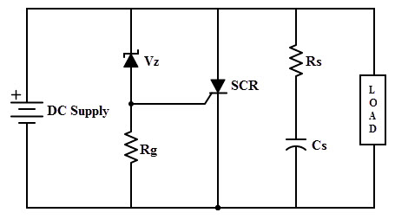](http://www.electronicshub.org/wp-content/uploads/2015/05/7.jpg)

***Op Amp Regulator with Series-Pass Transistor***

CIRCUIT

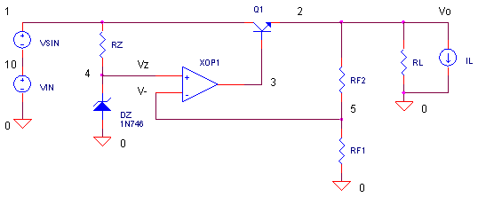

What is the function of a voltage regulator circuit? It’s basically this - maintain a precise voltage regardless of the current drawn by the load. Three basic components are needed to achieve good voltage regulation.

1. A precision reference (zener diode) to set the output voltage.

2. A muscle component (transistor) to deliver the required current.

3. An automatic controller (opamp) to adjust the transistor drive. The “prime directive” of the op amp is to adjust the base drive of Q1 delivering the required load current while keeping the output voltage at a fixed value.

OUTPUT VOLTAGE

Resistors RF1 and RF2 feed a fraction of the regulator output Vo to the op amp's negative input V-. The op amp then adjusts the drive to Q1 such that V- is equal to the zener voltage Vz. When this occurs, the output voltage is related to the zener voltage through the RF1, RF2 divider by

http://www.ecircuitcenter.com/Circuits/opreg1/Image2.gif  .

SPICE FILE

OPREG.CIR - OPAMP VOLTAGE REGULATOR W/ SERIES-PASS TRANSISTOR

*

* INPUT VOLTAGE (VSIN FOR TEST ONLY)

VIN 10 0 DC 15

VSIN 1 10 SIN(0 0 1KHZ)

* SERIES TRANSISTOR

Q1 1 3 2 QNOM

* REFERENCE VOLTAGE

RZ 1 4 5K

DZ 0 4 D1N746

* OPAMP CONTROLLER

XOP1 4 5 3 OPAMP1

RF2 2 5 10K

RF1 5 0 5K

* LOAD

RL 2 0 100

*IL 2 0 PWL(0 0 10MS 0 10.1MS 1 20MS 1 20.1MS 0 30MS 0)

*

.model QNOM NPN(BF=100)

.model D1N746 D(Is=5u Rs=14 Bv=2.81 Ibv=5u)

*

* * OPAMP MACRO MODEL, SINGLE-POLE

* connections: non-inverting input

* | inverting input

* | | output

* | | |

.SUBCKT OPAMP1 1 2 6

* INPUT IMPEDANCE

RIN 1 2 10MEG

* GAIN BANDWIDTH PRODUCT = 10MHZ

* DC GAIN (100K) AND POLE 1 (100HZ)

EGAIN 3 0 1 2 100K

RP1 3 4 1K

CP1 4 0 1.5915UF

* OUTPUT BUFFER AND RESISTANCE

EBUFFER 5 0 4 0 1

ROUT 5 6 10

.ENDS

*

* ANALYSIS

.TRAN 0.05MS 30MS

* VIEW RESULTS

.PRINT TRAN V(2)

.PLOT TRAN V(2)

.PROBE

.END